A REPORT ON HERBALISTS’ ASSESSMENT AT NCRI BY DIRECTORATE OF INDUSTRIAL TRAINING (DIT) MINISTRY OF EDUCATION AND SPORTS

BY
DR. GRACE NAMBATYA KYEYUNE
DIRECTOR OF RESEACH NATURAL CHEMOTHERAPEUTICS RESEARCH INSTITUTE

OCTOBER 2019

REPORT ON HERBALISTS’ ASSESSMENT AT NCRI BY DIRECTORATE OF INDUSTRIAL TRAINING (DIT) MINISTRY OF EDUCATION AND SPORTS

Introduction
Due to growth in utilization and trade in herbal medicine products in Uganda, Natural Chemotherapeutics Research Institute (NCRI) and Directorate of Industrial Training (DIT) established collaborations to formalize training of herbalists and herbal medicines processors. This is a means to improve their practice and formalize the sector.
Main Objective
To assess the trainees learning ability.
Method of Assessment
Periodic assessment of the trainees was done through exercises, quizzes, take home individual and group assignments given with regard to each module. Pre assessment was individually done by each of the trainee candidate. The final assessment of the trainees was conducted by officials from the Directorate of Industrial Training (DIT) on 2nd and 3rd October 2019.
Test questions required each trainee candidate to prepare and package respective herbal products.
A total of 19 trainee candidates were assessed for a worker’s pass and 2 trainee candidates were for modular assessment, by DIT officials.
Each trainee was either to pass or fail as per the respective grades/ levels set by DIT officials.

APPENDIX: Pictorial presentation of the candidates during assessment.
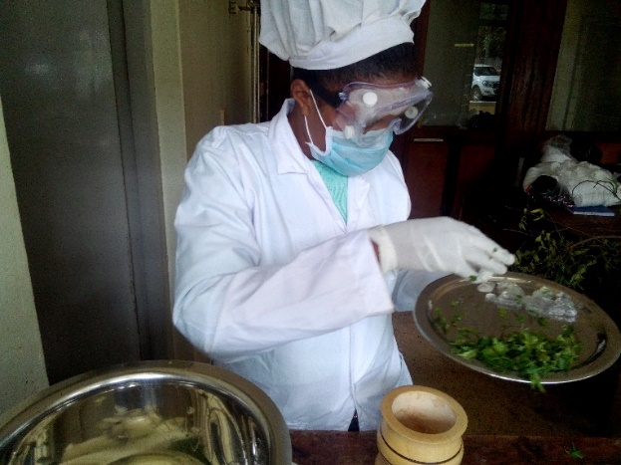1a 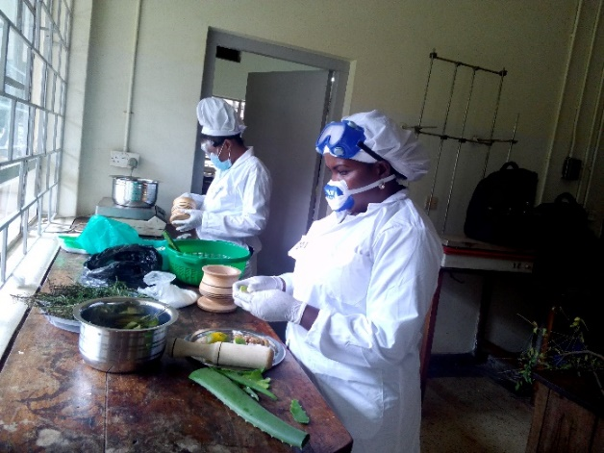1b
Figures 1a and 1b session for modular assessment in progress.
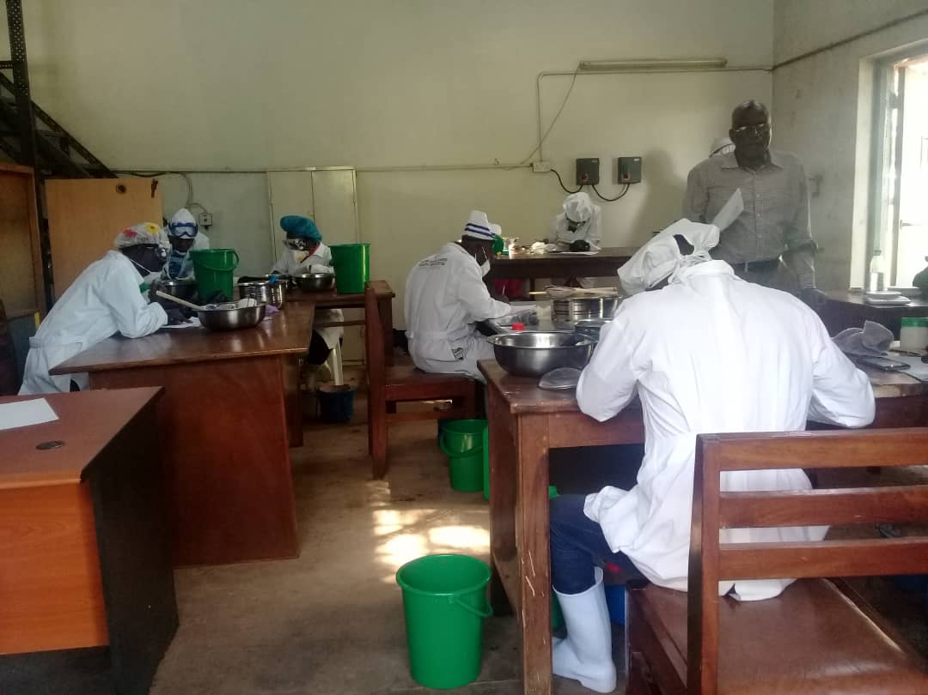 2a 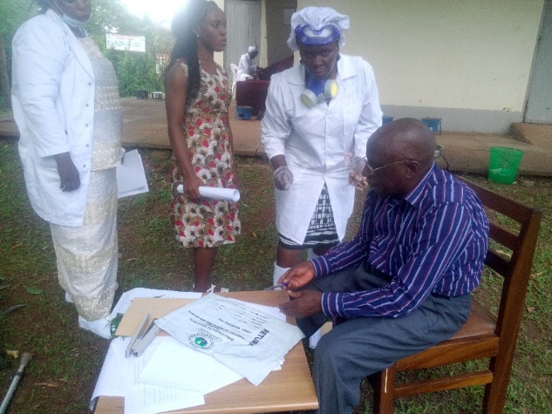 2b
Figures 2a and 2b, Candidates receiving instructions from DIT supervisors

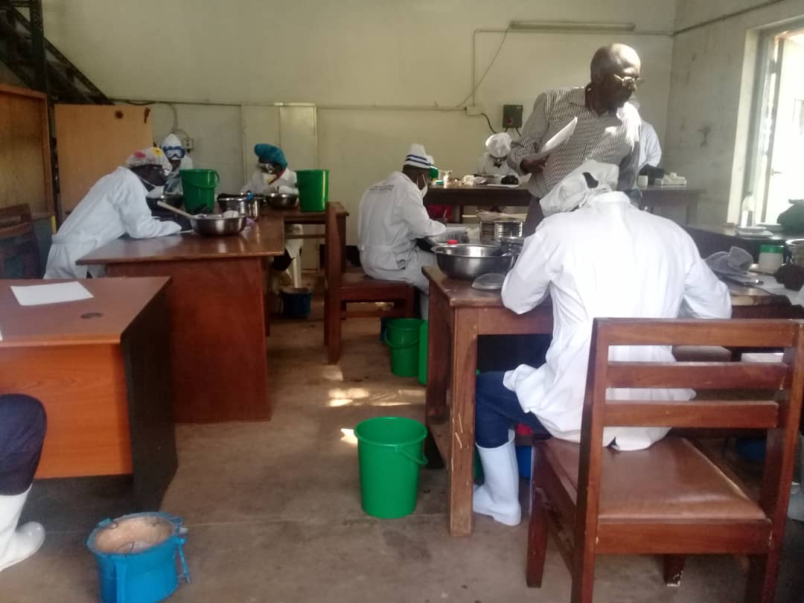 3a 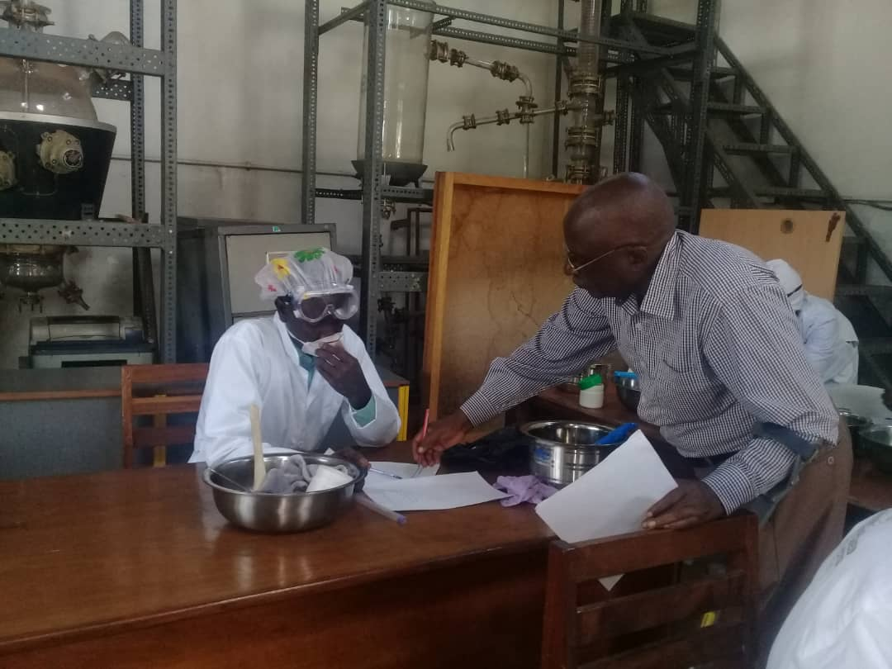3b
Figures 3a and 3b, DIT Supervisor invigilating worker’s pass examination.
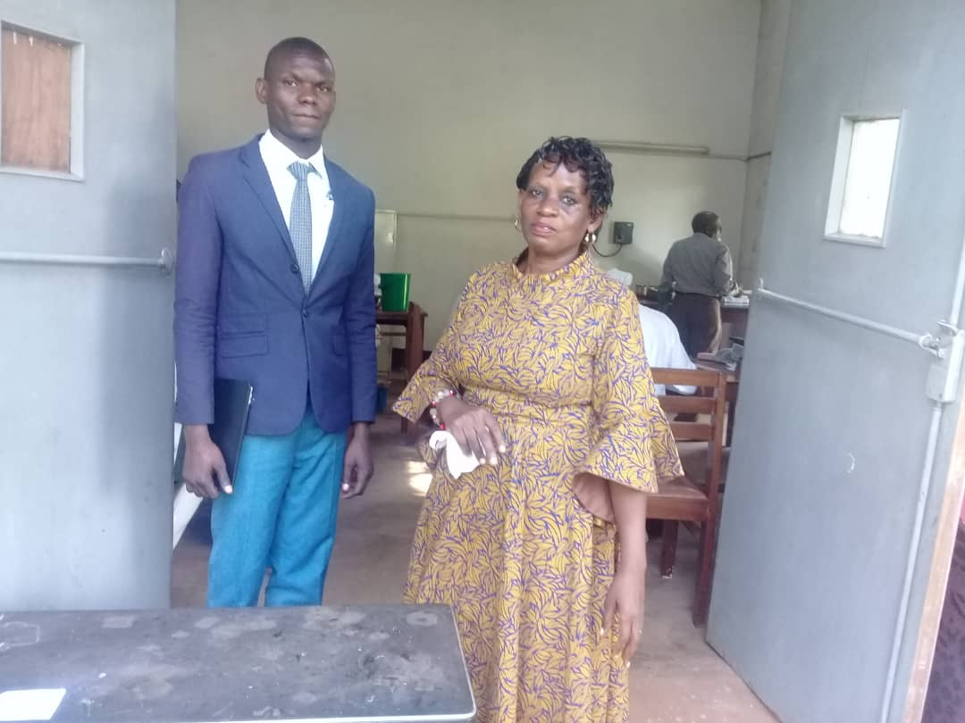4
Figure 4, Director of Research NCRI and staff, after checking on exam progress.
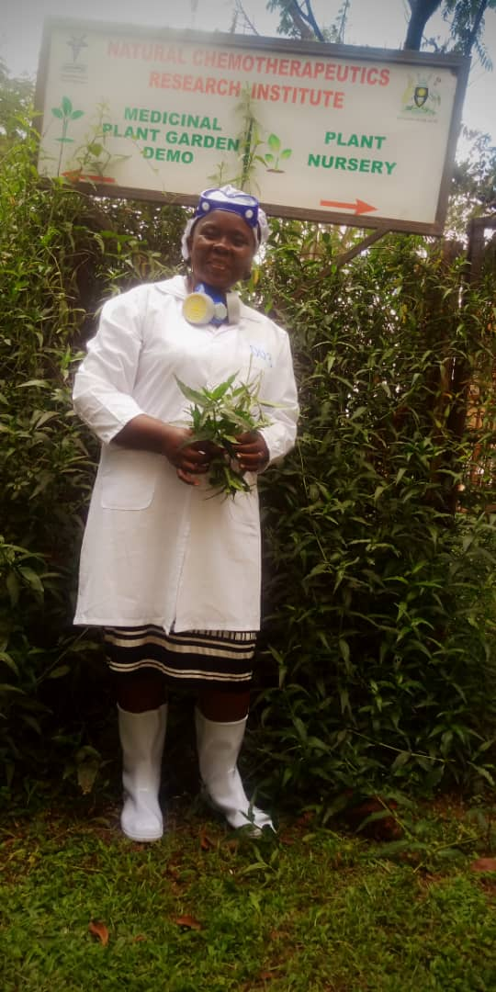 5a 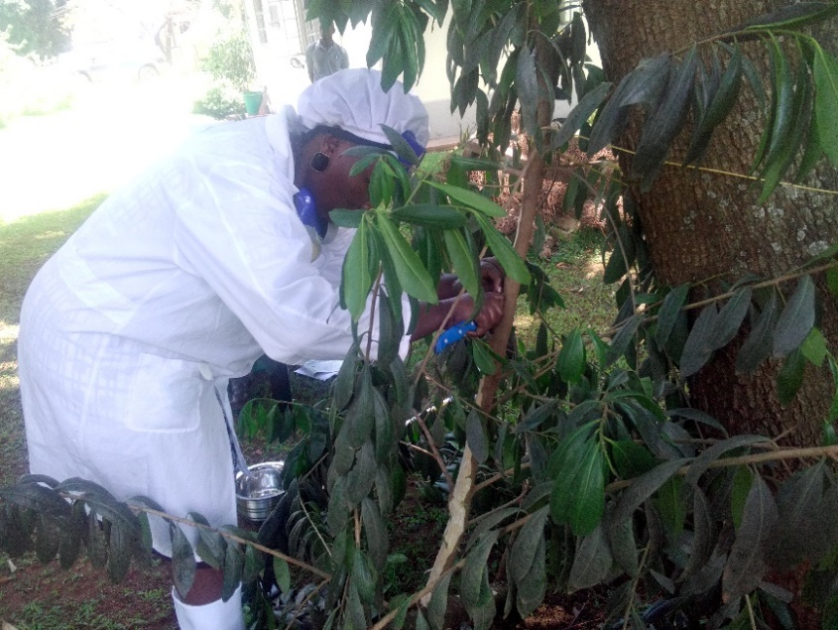5b
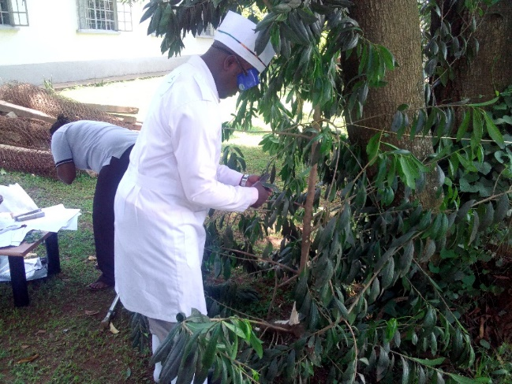 5c 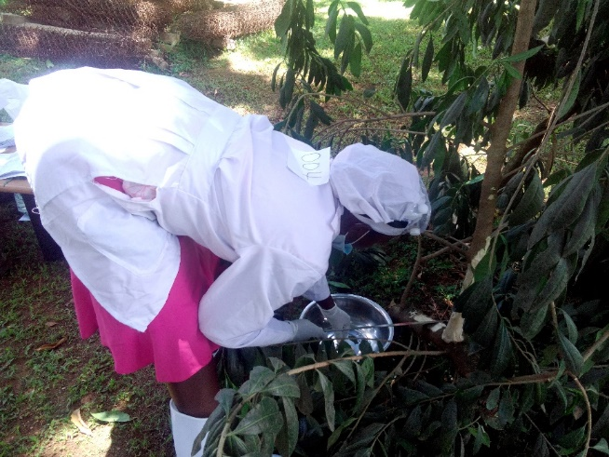5d
Figure 5; a,b,c,d; candidates harvesting raw plant material for formulation of herbal products during the examination session.

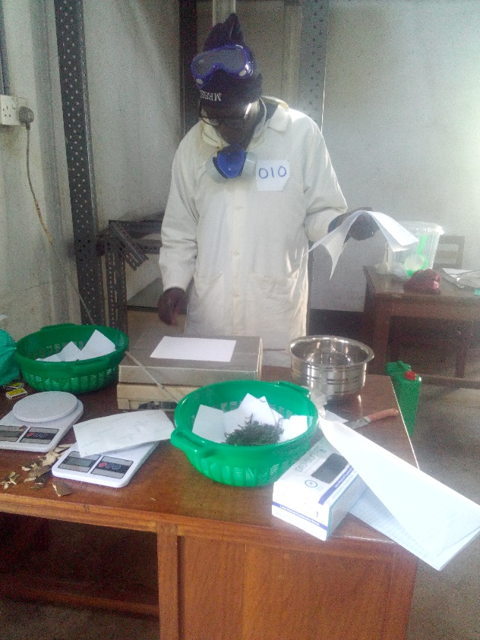6a 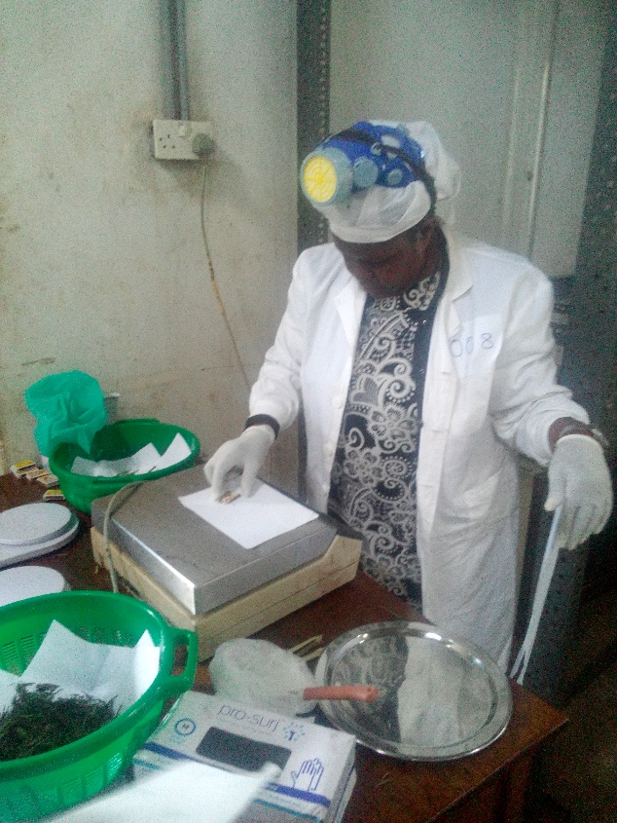6b
Figure 6 a and b, candidates taking weights of the various ingredients.

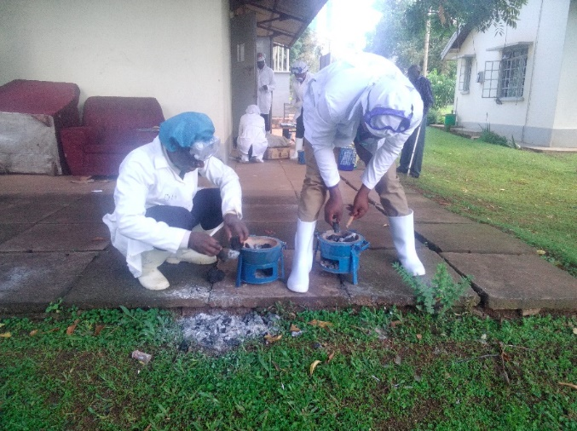7a 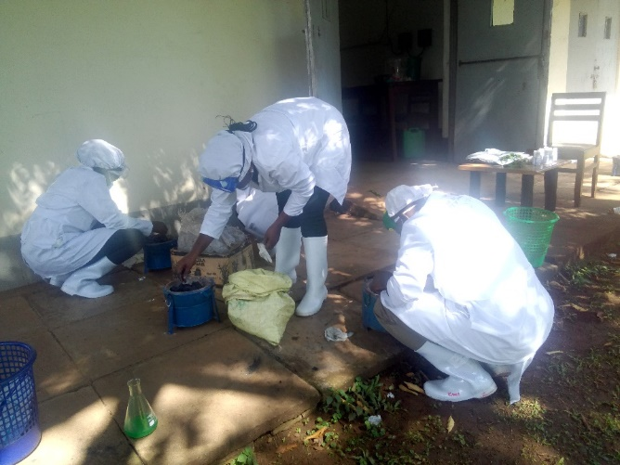7b
Figure 7 a and b, Candidates lighting heating sources.
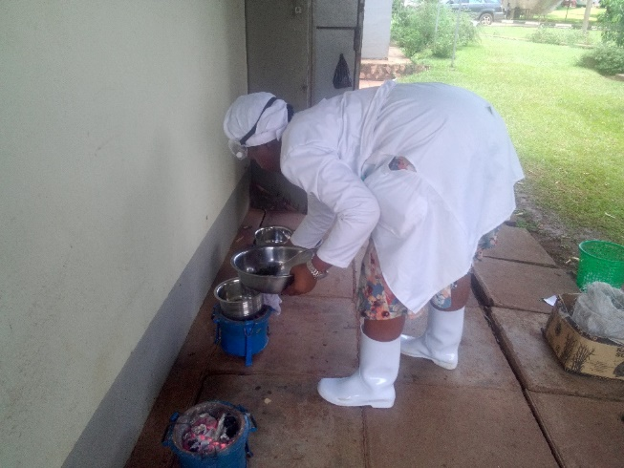8a 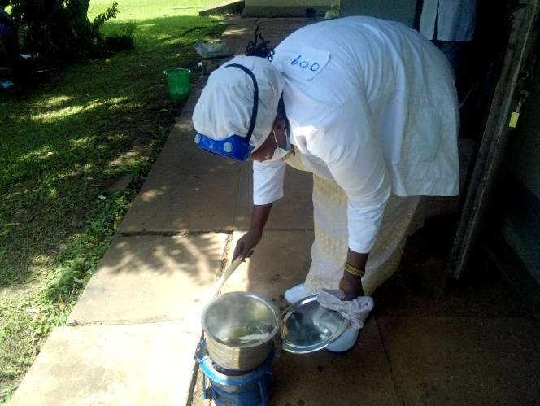8b
Figure 8a and b, Candidates monitoring progress of decoction on fire
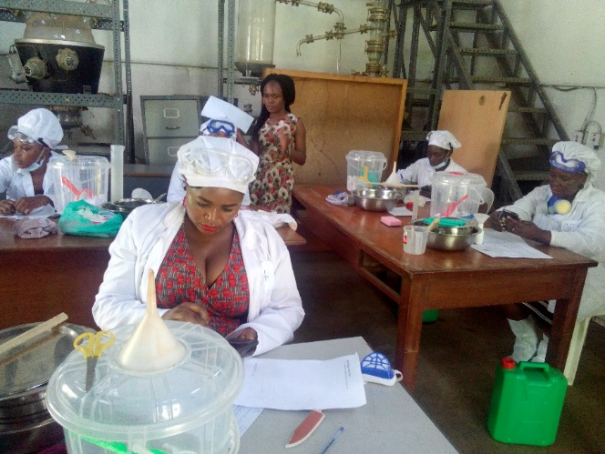9a 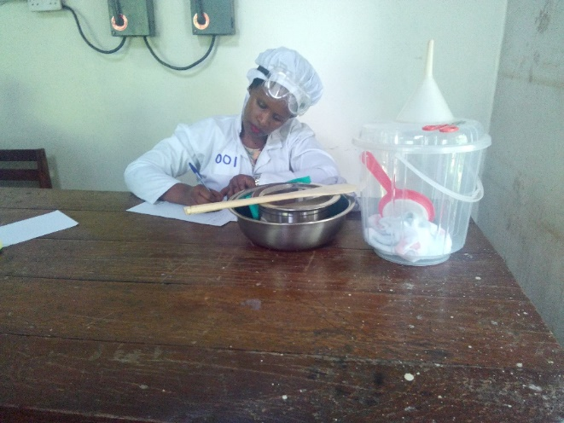9b
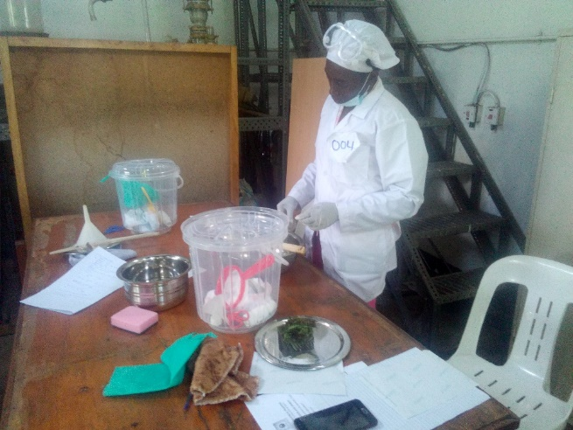 9c 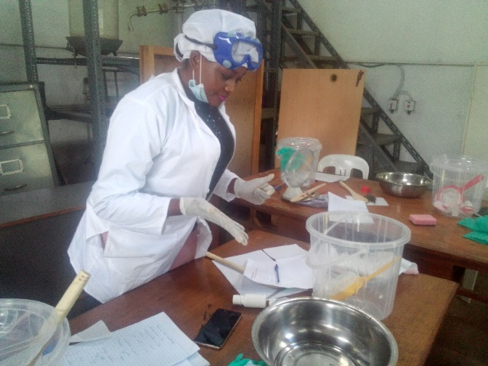9d

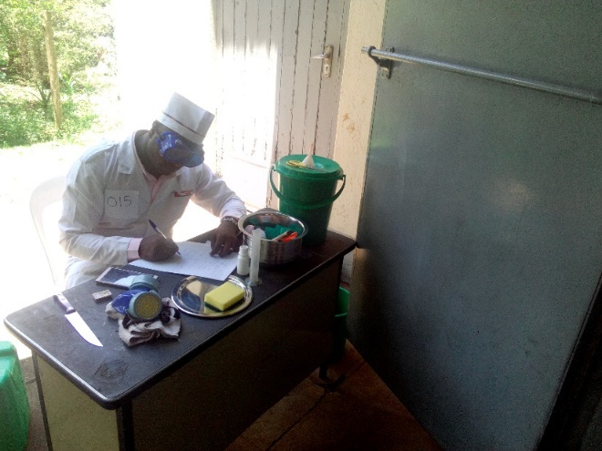 9e 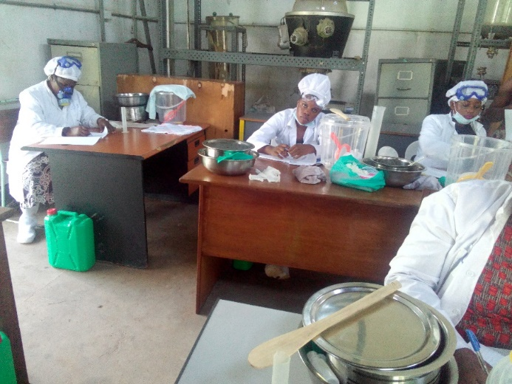9f

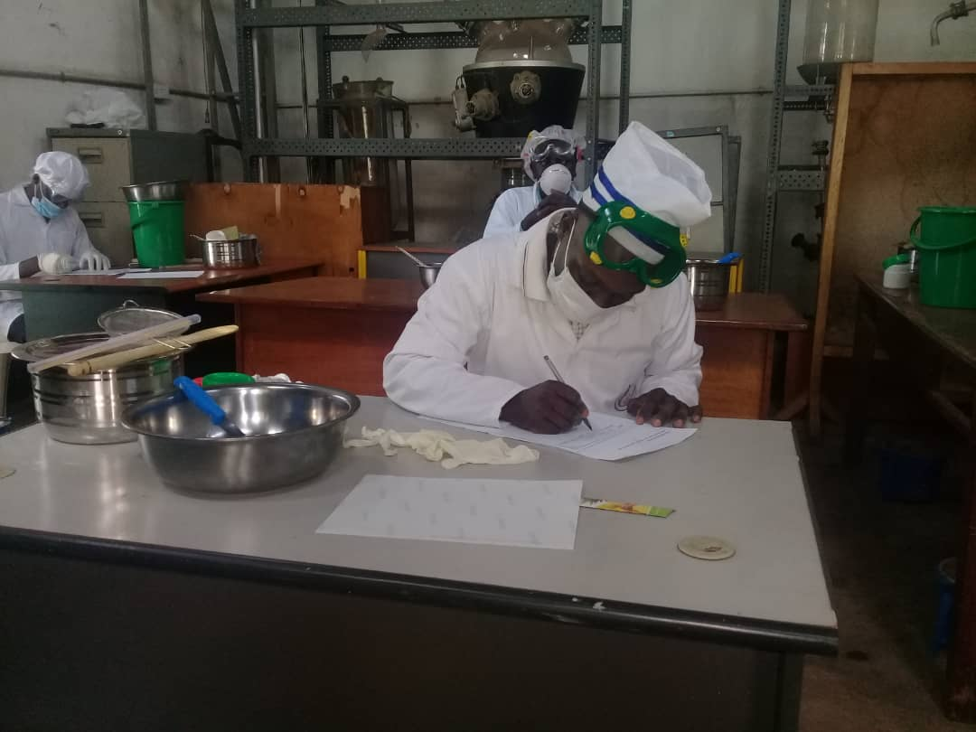9g 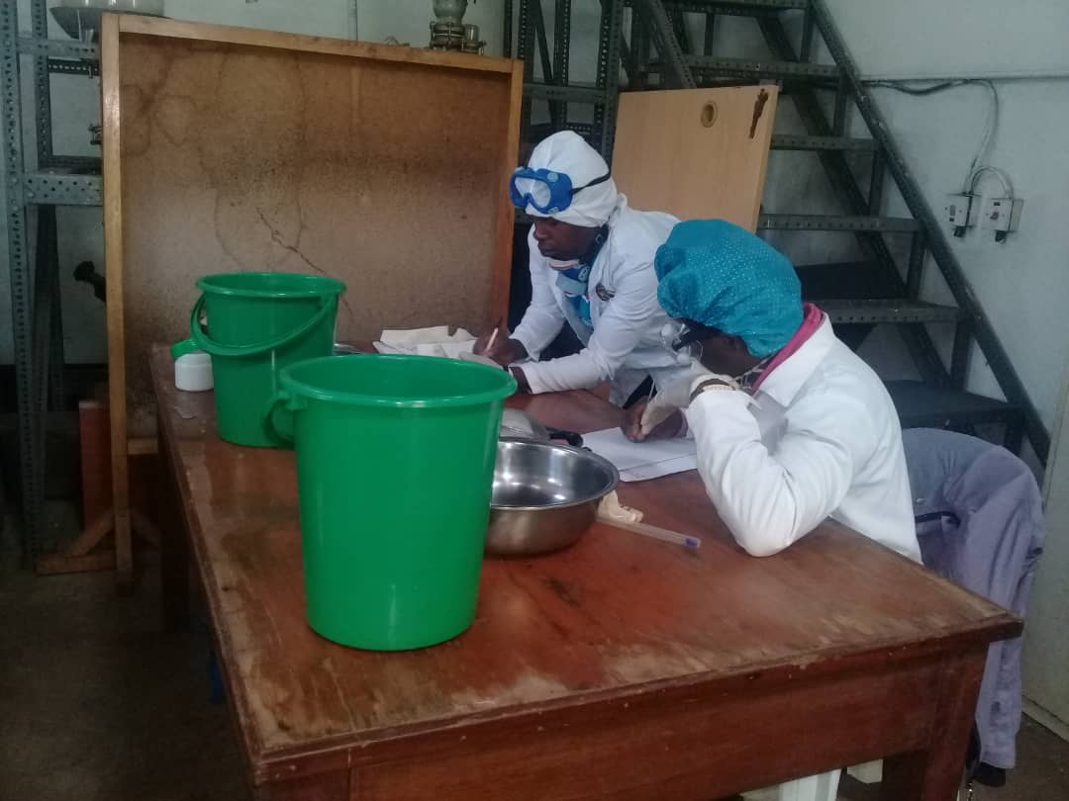9h

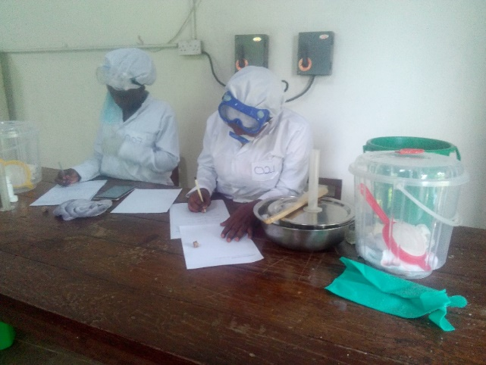 9i 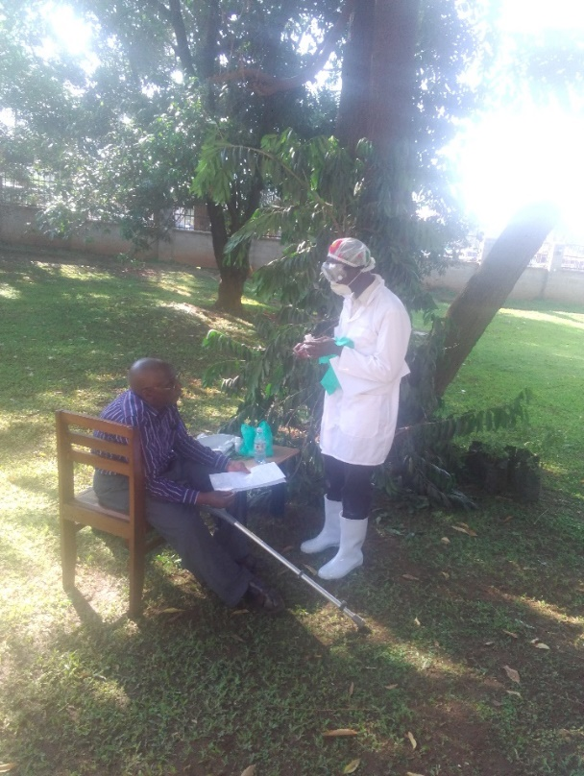9j
Figures 9; a, b ,c, d, e, f, g, h, i and j, Examination for a worker’s pass in progress

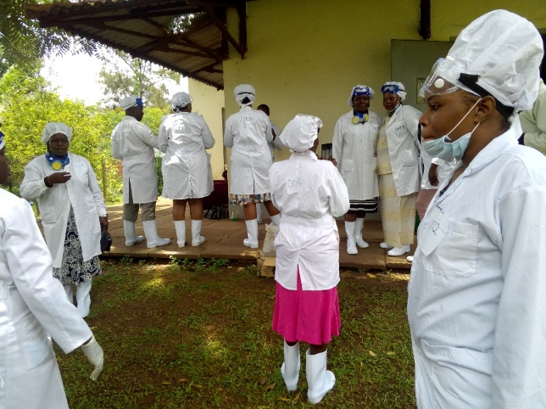 10a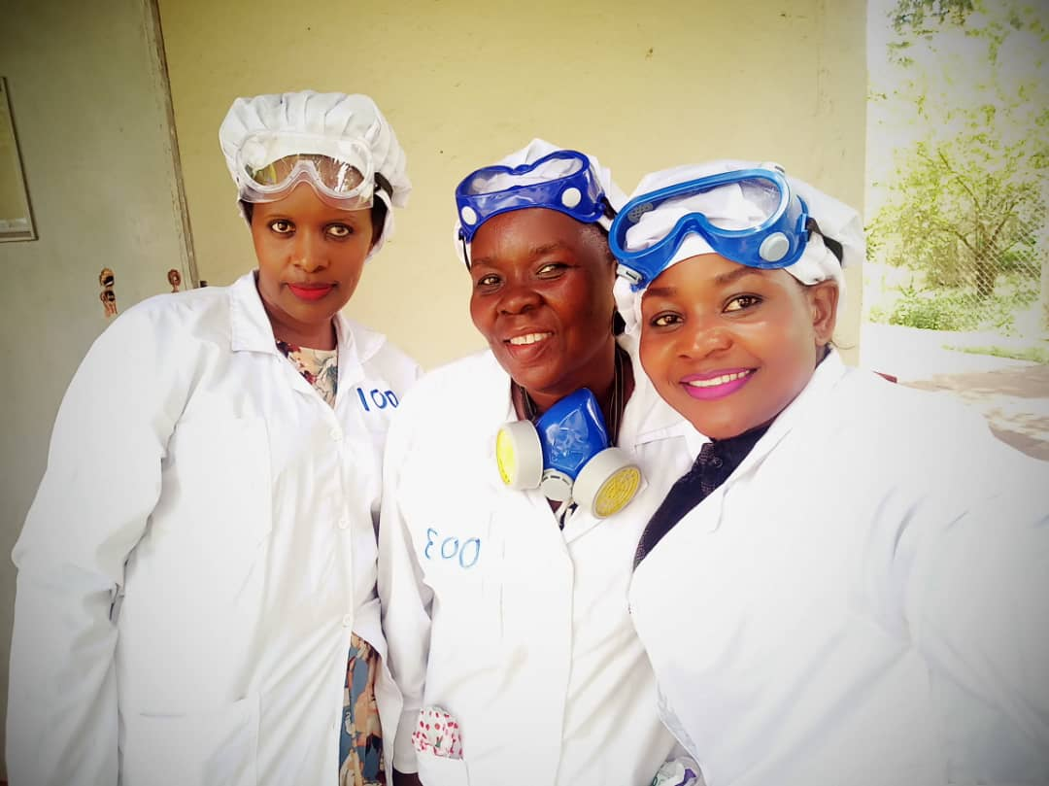10b

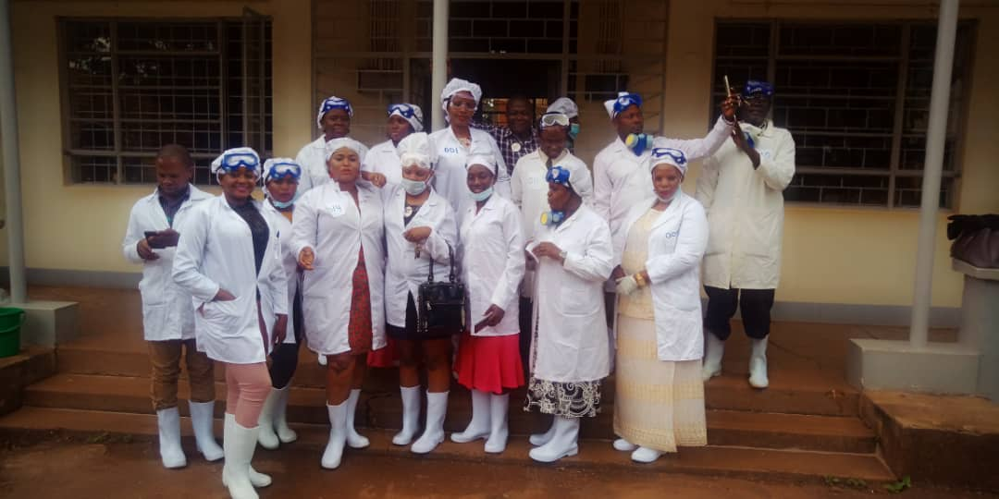10c
Figure 10 a, b and c; Candidates in a lighter moment after Examination.

ACKNOWLEDGEMENTS
We are grateful for the continued support from the government of Uganda through Ministry of Health and partners.

